Find a Companion.

Design, Evaluation and Development

Hannah Wilson | WEB701 Web Technology | 02/03/2021

Contents

Executive Summary/ Abstract 1

Designing the website. 3

Website Brief 3

What are the Website requirements? (using Information Architecture analysis) 4

Site Goals 4

Define the User experience 4

Site Content 4

Site Structure 5

User Stories – Designing to build 6

CRUD analysis – API prototype 6

Evaluating web technology – which to use.? 7

Developing the website 8

# Introduction

# Designing the website.

## Website Brief

The members of the Adopt a Companion are interested in having a website of their own. The following is brief description on the proposed website:

|  |
| --- |
| The Adopt a Grandparent Charity is a “companion style” charity in the Nelson region who offer their companionship for the elderly, or mentorship for youth in the local community.  We need a website for the Nelson region for members of the charity to provide companionship for the elderly and young.  The purpose of the new website is to help match up youths with and elderly person. This can be an elderly person who is looking for a bit of companionship, or to mentor a younger person that does not have grandparents in their life, and vice versa. The website lets members register and specify their availability from days of the week to times of day.  The website lets members of the community (Users) access the service, by providing tokens that can be “spent” in the service. To achieve our goal, we would like to have an online token function on our website that lets a User access a limited number of tokens, for example the system needs a mechanism that verifies that a member of the community is accessing the service and that the token belongs to a particular community member. The website needs some homepage text about general information of our products and services such as: types, characteristics, quality factor, usage, and benefit.  We require the following features on the website:  1.   Charity members and Users can register, log in and administer their own accounts.  2.   Members use the website to register their products and services, and beneficiaries use the system to acquire tokens.  3.   Interactive element(s) that engages the website user.  4.   The system provides an interface that the members can use to [accept](https://ecampus.nmit.ac.nz/moodle/mod/glossary/showentry.php?eid=9771&displayformat=dictionary) a token in a transaction. |

## What are the Website requirements? (using Information Architecture analysis)

### Site Goals

The goal of the site is to match up young people with elderly people in a companionship/mentoring relationship that both parties benefit from.

#### Mission or purpose of the website.

#### Short- and long-term goals.

* Short term goals of the website are to match up compatible users with each other.
* Long term goals are to create long lasting relationships that both parties will benefit from.

#### Intended audiences (a brief overview)

* Elderly people from the age of 60 with no close grandchildren that are looking for a grandparent type roll.
* Elderly people looking to mentor younger people in a variety of activities.
* Preschool aged children to 30s looking for a surrogate grandparent.
* Preschool aged children to 30s looking for a mentor to learn from.

#### Why will people come to the website?

To apply to be matched up with a companion.

### Define the User experience

Upon registering an account, each user will be given a ‘token’. For charities they can use this ‘token’ to register a service. For beneficiaries this ‘token’ will be used to apply for a match.

#### The Audience

* Organizers of the charity group who will match up the users.
* Elderly people from the age of 60 with no close grandchildren that are looking for a grandparent type roll.
* Elderly people looking to mentor younger people in a variety of activities.
* Preschool aged children to 30s looking for a surrogate grandparent.
* Preschool aged children to 30s looking for a mentor to learn from.

#### Scenarios and Personas

Write 3 to 4 short scenarios that describe how the website is going to used. Write “grungy” persona descriptions.

* Ethel Beavers:
  + 69-Year-old widow.
  + Lives alone in a four-bedroom house.
  + Likes to knit, crochet, do jigsaw puzzles.
  + Used to be a nurse.
  + Would like to mentor someone in the art of knitting and crochet.
  + Is available every day of the week, except for Thursday evenings when she plays bowls.
* Wallace Wellington:
  + 86-year-old widower.
  + All his siblings and friends have passed away.
  + Has not heard from his grandchildren since his wife passed away and they asked for their inheritance.
  + Currently resides at Summerset Retirement Village, dislikes the food and company provided there.
  + Would like to find a young lad to tell old war stories too and get up to some mischief.
* Charlie Addington:
  + 12-year-old boy.
  + Only child.
  + Lives with single mother.
  + Does not have a father or grandparents.
  + Wants to learn how to do carpentry.
  + Looking for someone to provide mentorship.
* Lizzy Flemming
  + 11-year-old girl.
  + Eldest of 5 children
  + Mother and father work fulltime.
  + Spends time after school helping look after younger siblings.
  + Would like to learn how to do cross stitch.

#### Competitive Analysis

* GrandFriends: <https://www.grandfriends.nz/>
  + Front page:
    - Has a nice colour scheme, heading, subheading and slogan.
    - Nav bar with; Home, About Us, News, Meet & Match, Get Involved, Contact Us(highlighted).
    - At top of page there is a link to donate to the charity.
    - Scroll down to a welcome title and introduction to what the charity is about.
    - Video introducing some of the participants and their experience with the charity.
    - Explanation on how GrandFriends works.
    - Testament from participant.
  + Contact Us Page:
    - Title: Ways to Contact Us
    - Phone number, email address, ‘message form’ and subtitle
    - Message form with first and last name, email address, and message inputs as well as ‘send’ and ‘reset’ buttons.
  + Join Us page:
    - Has steps on how to apply to join.
    - Informs of vetting processes that need to occur before someone is accepted.
  + Meet & Match Page:
    - Displays a map of NZ with locations of locations of meet up locations and locations of other participants (needs a key showing difference between the two though).
    - Option to search by region.
  + Get Involved Page:
    - Details on how to donate.
    - Links for signing up to volunteer.
  + Cons:
    - One of the only cons about this website is the need to scroll all the way to the top of the age to get to the navigation bar.

* Surrogate Grandparents: <https://www.meetup.com/Surrogate-Grandparents-NZ/>
  + Main Page:
    - Very bland, lots of white space.
    - Dull grey colours for title and icon.
    - Nav bar with tbs; About, Events, Members, and Photos.
    - Two small paragraphs on what the site is about.
    - Link to a Facebook page for the group.
    - Past Events and Photos cards.
    - Right side bar with Members and Organizers cards.
  + Events Page:
    - Two upcoming events with time, date, location, description of event.
  + Members Page:
    - Option to sign up and login through Facebook.
    - Shows list of member’s names and when they joined the group.
  + Photos Page:
    - Background changes to a dark purple with white card over top.
    - No photos, only logo.
  + Discussion page:
    - Empty.
  + Clean and concise site that is straight to the point with good information. Does not seem to have much activity or traffic coming through though.

* CHD Living Adopt a Grandparent: <https://chdliving.co.uk/aag-faqs>
  + A long-term care facility that offers an Adopt a Grandparent scheme.
  + All in one view
  + Nice banner with icon, logo, slogan, as well as charity logo.
  + ‘About Adopt a Grandparent’ heading:
    - Small, concise explanation on what the scheme/program is about.
  + ‘What’s Involved’ heading:
    - Explains how to get involved/participate.
    - Ways to contacts and interact with matches e.g., letter writing, phone calls.
  + Link to FAQ page.
  + Form to fill out and submit to apply to join.
  + A nice clean and brief page that is straight to the point while offering lots of information.

* Adopt a Grandparent: <https://adoptgrandparent.org/#page-content>
  + Main Page:
    - Nice big banner with slideshow of photos.
    - Nav bar at top right of banner.
    - Logo with icon and slogan located at top left of banner.
    - Banner contains ‘Get Involved’ and ‘Become a Volunteer’ buttons centre of banner.
    - ‘Let’s combat Loneliness’ title with small brief paragraphs stating what the site is about/for.
    - A righthand side bar containing two videos that are not in English (I am guessing these are user testimonials).
    - Small title ‘Ways you can help’ with bullet pointed list of suggestions.
    - ‘How to adopt a Grandparent’ title with register form underneath.
    - Ways to contact group with phone number, email address, and Facebook page.
    - Bottom banner with logos and links to other sites that are not in English.
  + Adopt Page:
    - Just scrolls down to register form at the bottom of the main page.
  + Volunteer/Contact Page:
    - Scrolls down to ‘Join Team’ and ‘Contact Us’ area of main pages.
  + Lots of white/empty space. Nav bar leads me to think there are more pages/information contained on the website when there is not.
  + Group does not say very much about themselves or elaborate on how successful, they are or have been. No mention of how many members they have. No readable testimonials from participants.
  + Not much of a colour scheme.

### Site Content

#### Content and Functional requirements

Write a summary of the required content of the website and list the Functional requirements.

Content includes written text, images, forms, navigation within the website. Functional requirements are identified in the brief.

Site Content:

* Main Page:
  + Navigation bar with ‘About’, ‘How to Join’, ‘Login/Register’, ‘Manage Account’, ‘contact Us’ buttons.
  + Banner with name, icon, and slogan.
  + ‘Welcome’ title with paragraph underneath saying what site is about.
  + Stock photos.
* About Page:
  + Navigation bar and banner as on main page.
  + ‘About Us’ Heading.
  + Paragraph or two on what the charity is about and how it works.
* ‘How to Join’ Page:
  + Navigation bar and banner.
  + ‘How to Join’ heading.
  + Paragraph or two on how the application process works.
* ‘Contact Us’ Page:
  + Navigation bar and banner.
  + ‘Contact Us’ heading.
  + Phone Number.
  + Email address.
* ‘Login/Register’ Page:
  + Navigation bar and banner.
  + ‘Login/Register’ heading.
  + Input boxes for email address, username, password.
  + Login/Register Button
* ‘Manage Account’ Page:
  + Navigation bar and banner.
  + ‘Manage Account’ heading.
  + ‘Edit Account’ Button – leads to pop up view with form with first and last name, address, phone number inputs.
  + Number of Tokens counter.
  + ‘Current Applications’ card with active or pending applications for a match.
  + ‘Current Matches’ card showing current matches that a user has.

#### Group and Label your Content.

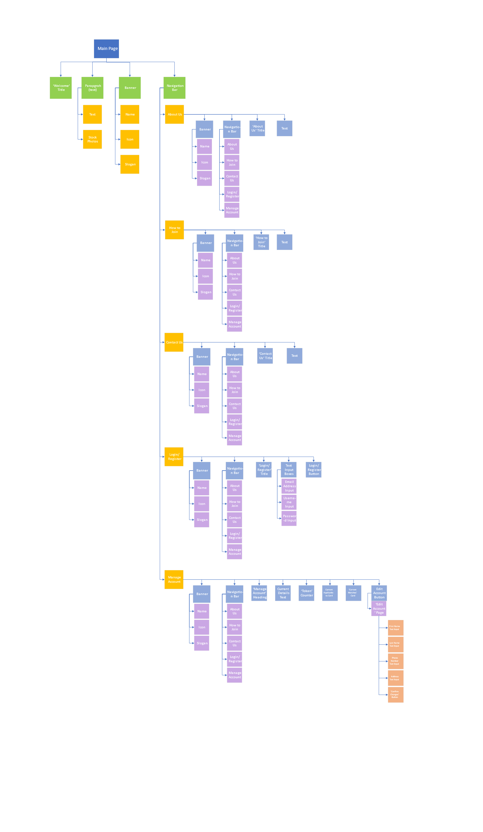

### Site Structure

#### Metaphors

Write a brief definitional of :

Organisational metaphor

Functional metaphor

Visual metaphor

#### Site structure listing

Write a text based hierarchical listing of your website. This should come from your Grouping and Labeling work.

#### Architectural “blue print”

Create a graphical diagrammatic map of the site, that includes navigation links, e.g. a Visual representation of the site’s structure

#### Define navigation

In your diagram indicate Global navigation and Local navigation.

#### Visual Design

Create a series of layouts (in grid format), that depict parts of the website.

Mock up webpages – design sketches.

## User Stories – Designing to build

From your previous information architectural analysis , extract a series of User Stories, to be used in an Agile process. Your Scenarios and Functional requirements can guide your in this. Read here

<https://www.atlassian.com/agile/project-management/user-stories>

Write a list of features – this is actually identified in your previous analysis, from the “Blue Print” site structure diagram.

Create a “backlog list” of features (and tasks) you need to do to build the website.

### CRUD analysis – API prototype

Produce a CRUD table – details to come, that lists the proposed INSERTS (creates) , RETRIEVALS, UPDATES and DELETIONS of data required in the implementation of your website.

Create an API that implements these for your website. At least with testable “mockups”. of functionality,